We don't support .NET 4.0 extensions for Vault Explorer or Job Processor. The problem is that Vault Explorer and Job Processor are 3.5 applications. And a 3.5 application cannot load a 4.0 DLL. In these cases, you will usually see an error message like, "Could not load file or assembly 'Foo' or one of its dependencies. The system cannot find the file specified."
To fix, you need to switch your compile settings to .NET 3.5 or earlier.
To change the settings is a VS 2010 C# project, go to the Application tab in your project settings and change the Target Framework.
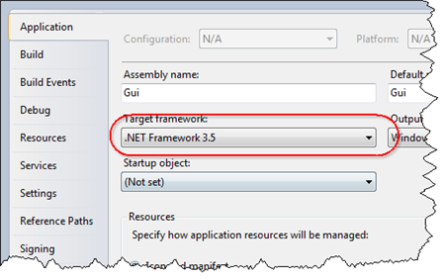
To change the settings is a VS 2010 VB.NET project, go to the Compile tab in your project settings and click the Advanced Compile Options button. In the dialog that pops-up, change the Target framework.
